**Module 4 – Test driven development and Logging framework**

**JUnit Testing Exercises**

**Exercise 1: Setting Up Junit**

**Aim:**

To set up JUnit in Java project to start writing unit tests.

**Implementation:**

I Implemented this in **VSCODE** by Installing Maven.

**Structure:**

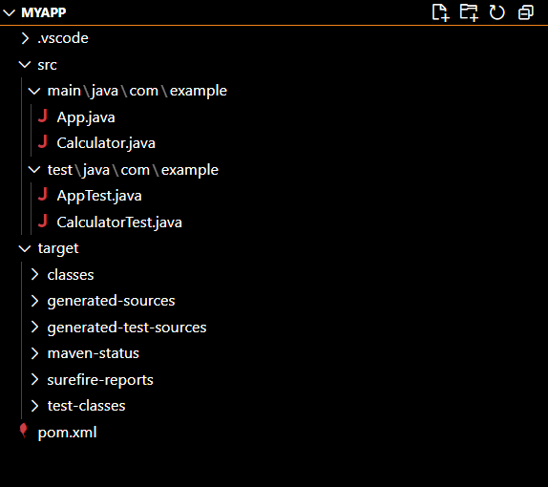

**pom.xml:**

<project xmlns="http://maven.apache.org/POM/4.0.0"

         xmlns:xsi="http://www.w3.org/2001/XMLSchema-instance"

         xsi:schemaLocation="http://maven.apache.org/POM/4.0.0 http://maven.apache.org/maven-v4_0_0.xsd">

    <modelVersion>4.0.0</modelVersion>

    <groupId>com.example</groupId>

    <artifactId>myapp</artifactId>

    <packaging>jar</packaging>

    <version>1.0-SNAPSHOT</version>

    <name>myapp</name>

    <dependencies>

        <!-- JUnit 4.13.2 for testing -->

        <dependency>

            <groupId>junit</groupId>

            <artifactId>junit</artifactId>

            <version>4.13.2</version>

            <scope>test</scope>

        </dependency>

        <!-- Required for JUnit 4 -->

        <dependency>

            <groupId>org.hamcrest</groupId>

            <artifactId>hamcrest-core</artifactId>

            <version>1.3</version>

        </dependency>

    </dependencies>

</project>

**Calculator.java**

package com.example;

public class Calculator {

    public int add(int a, int b) {

        return a + b;

    }

}

**CalculatorTest.java:**

package com.example;

import org.junit.Test;

import static org.junit.Assert.*;

public class CalculatorTest {

    @Test

    public void testAdd() {

        Calculator calc = new Calculator();

        int result = calc.add(2, 3);

        assertEquals(5, result);

    }

}

**App.java**

package com.example;

/**

 * Hello world!

 *

 */

public class App

{

    public static void main( String[] args )

    {

        System.out.println( "Hello World!" );

    }

}

**AppTest.java**

package com.example;

import junit.framework.Test;

import junit.framework.TestCase;

import junit.framework.TestSuite;

/**

 * Unit test for simple App.

 */

public class AppTest

    extends TestCase

{

    /**

     * Create the test case

     *

     * @param testName name of the test case

     */

    public AppTest( String testName )

    {

        super( testName );

    }

    /**

     * @return the suite of tests being tested

     */

    public static Test suite()

    {

        return new TestSuite( AppTest.class );

    }

    /**

     * Rigourous Test :-)

     */

    public void testApp()

    {

        assertTrue( true );

    }

}

**Output:**

